**JAVASCRIPT-Scalar**

1. **Introduction:**

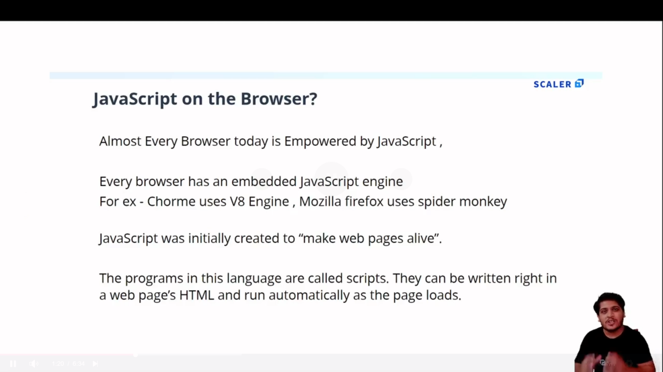

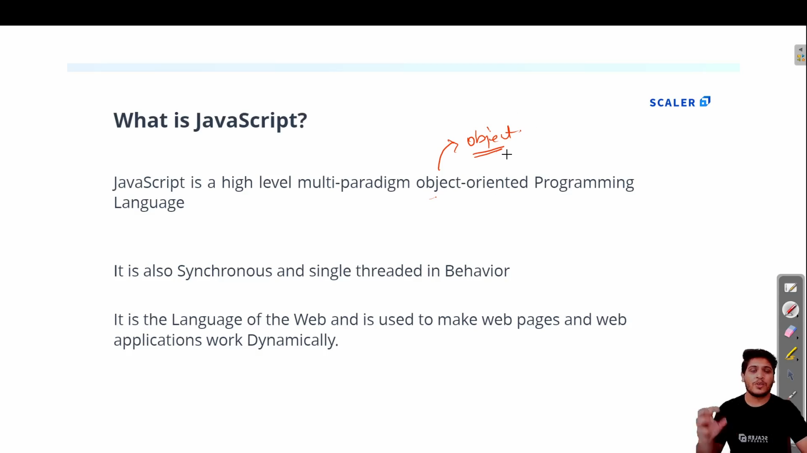

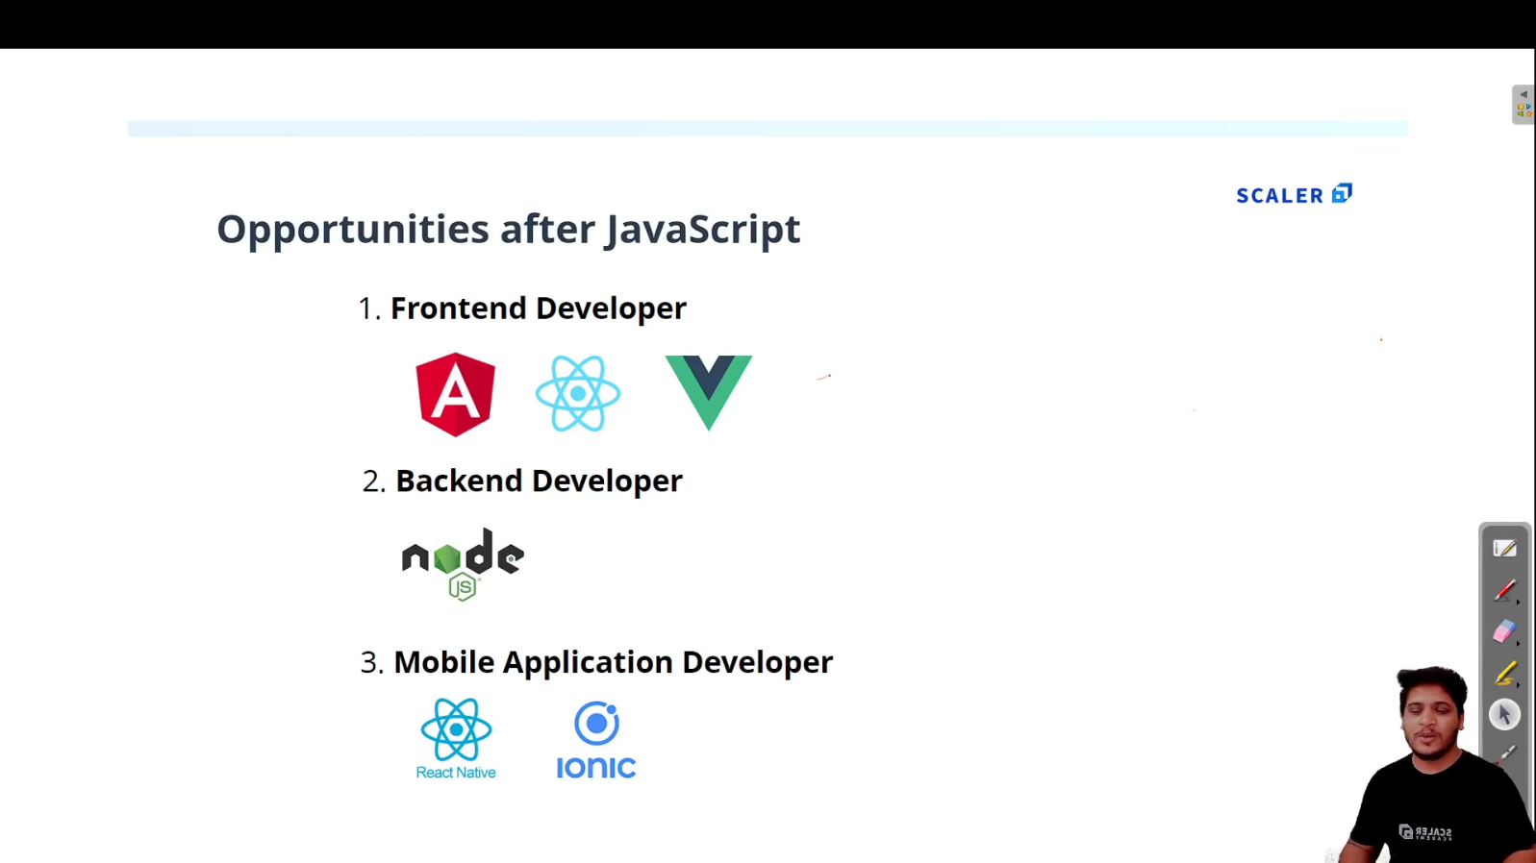

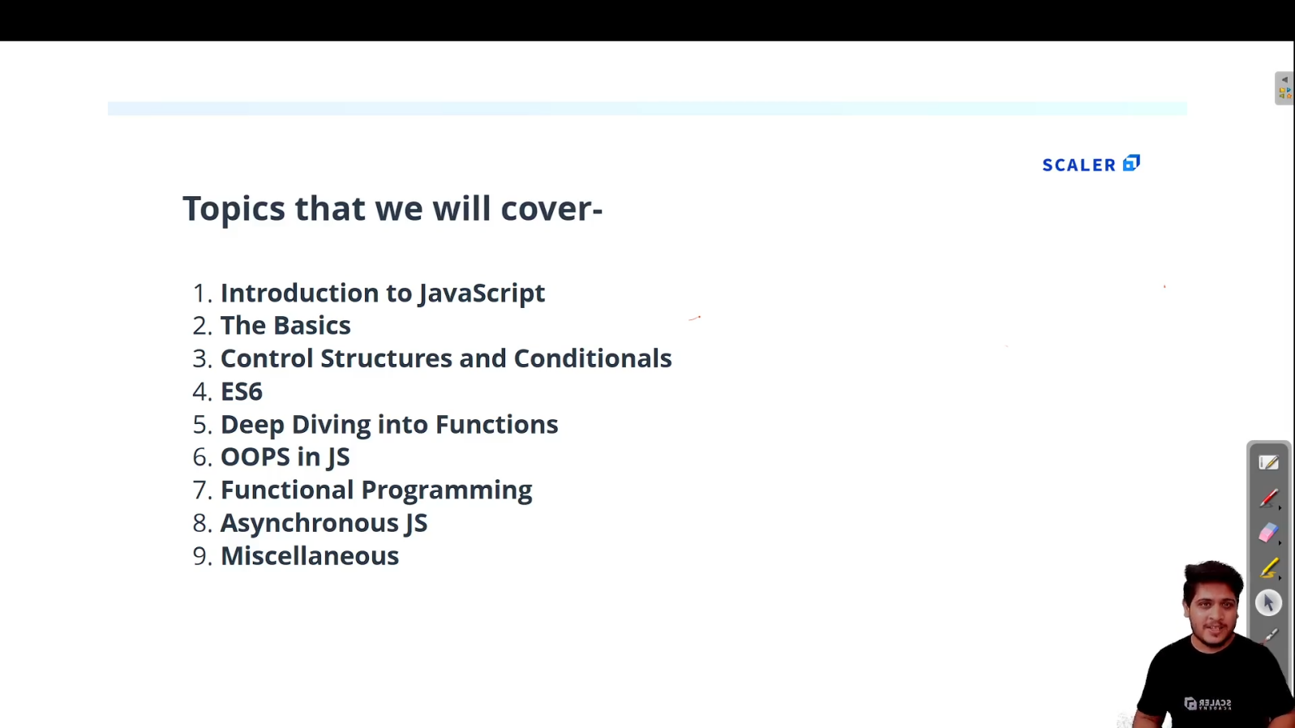

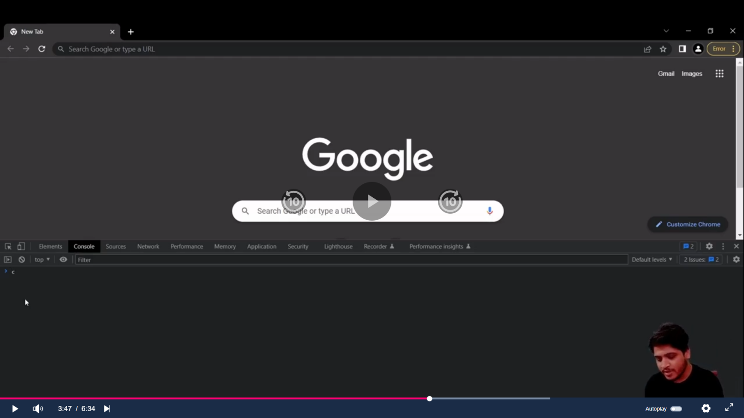

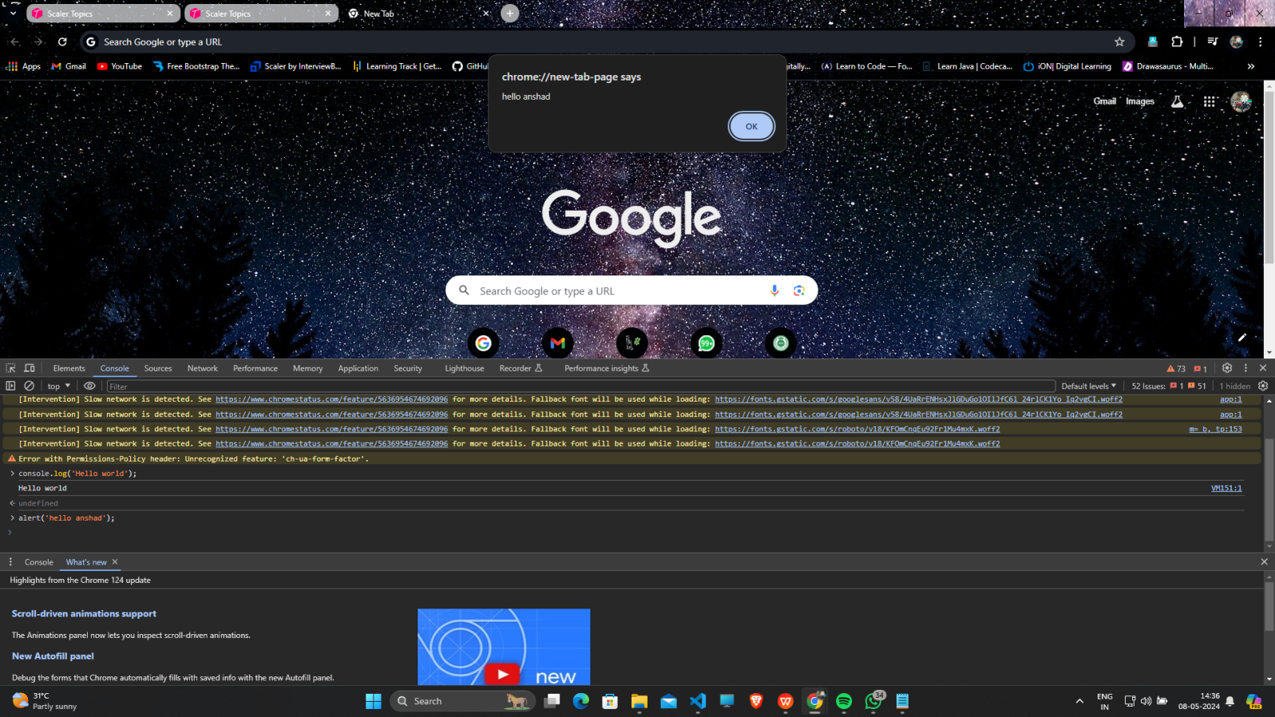

1. **First JS program :**
   1. **Create index.html and script.js file**

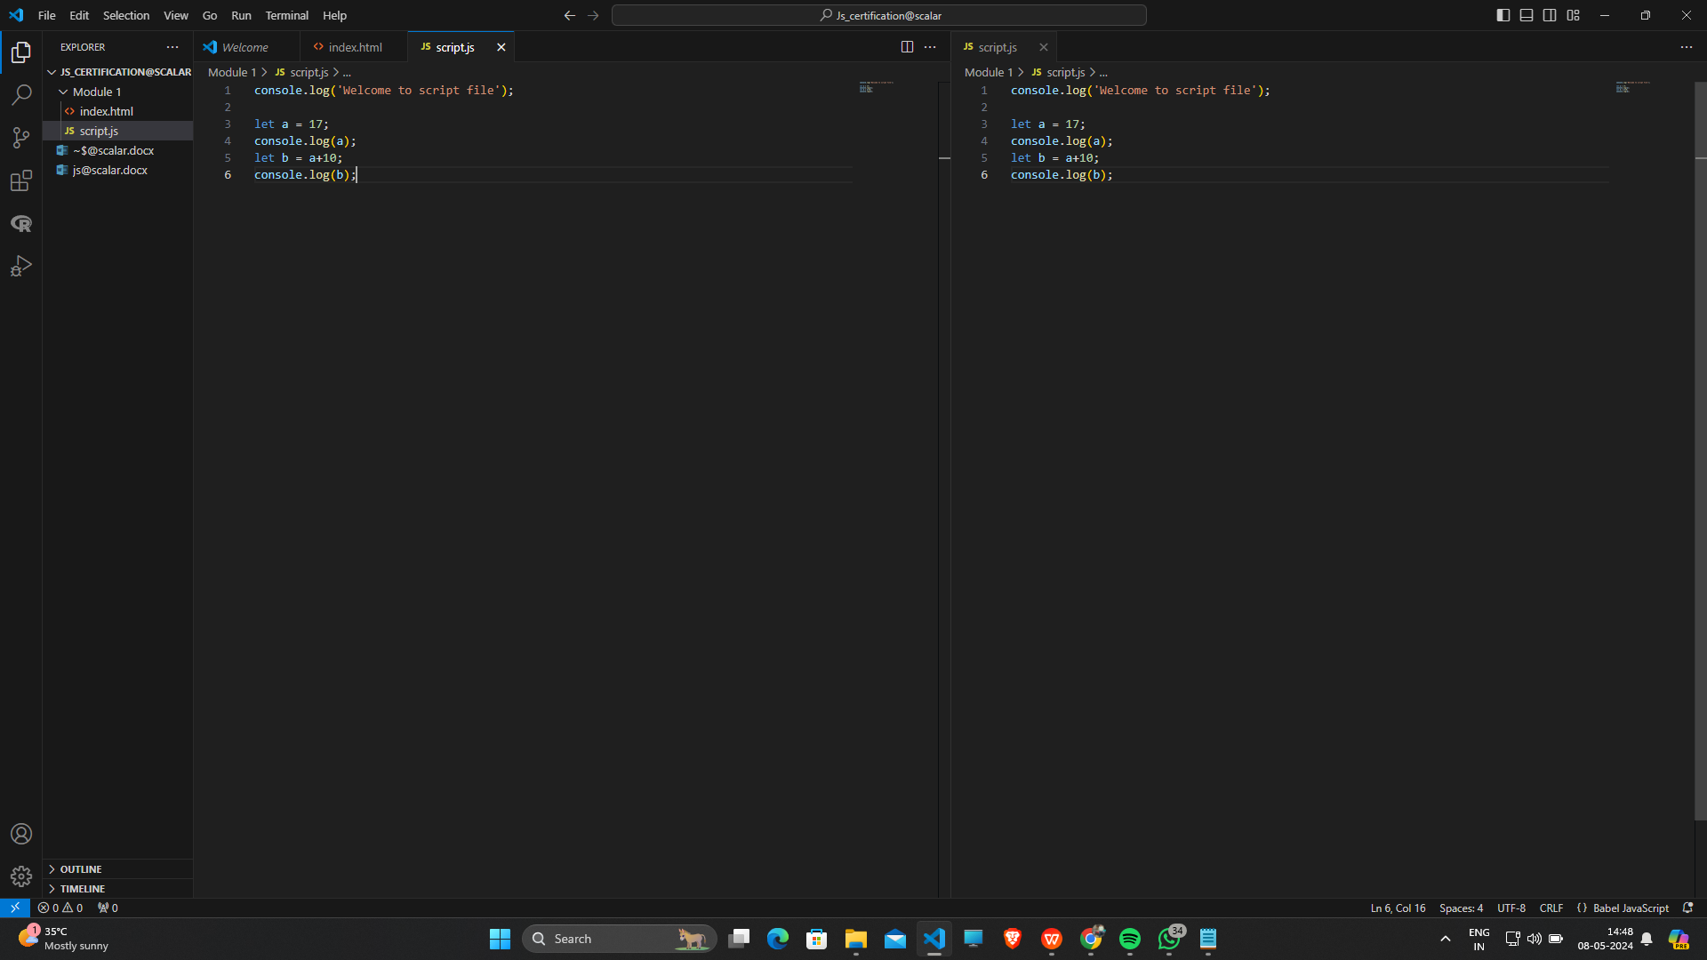

* 1. **To see Output ,open that index.html and inspect and go to console option :**

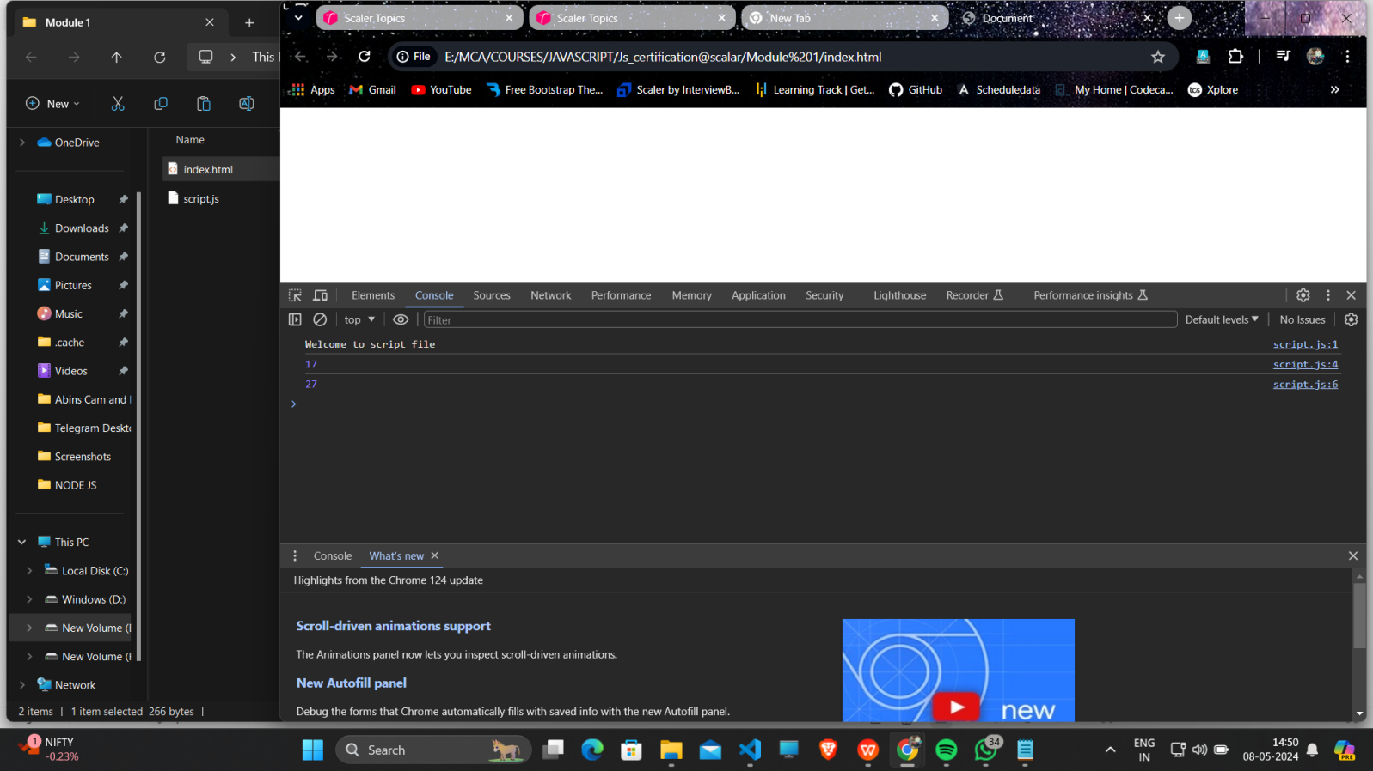

* 1. **Add an “Live Server” Extension to VScode so you can right click and select Open with Live Server ,which will directly take you to browser.**

1. **Variables in JS :**

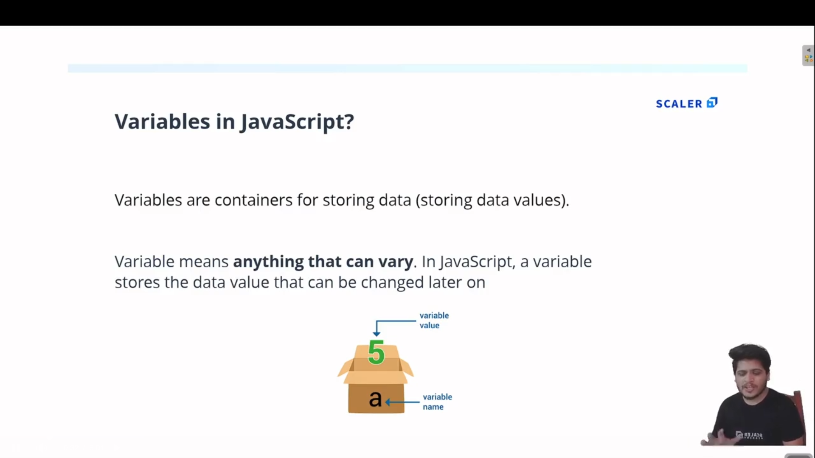

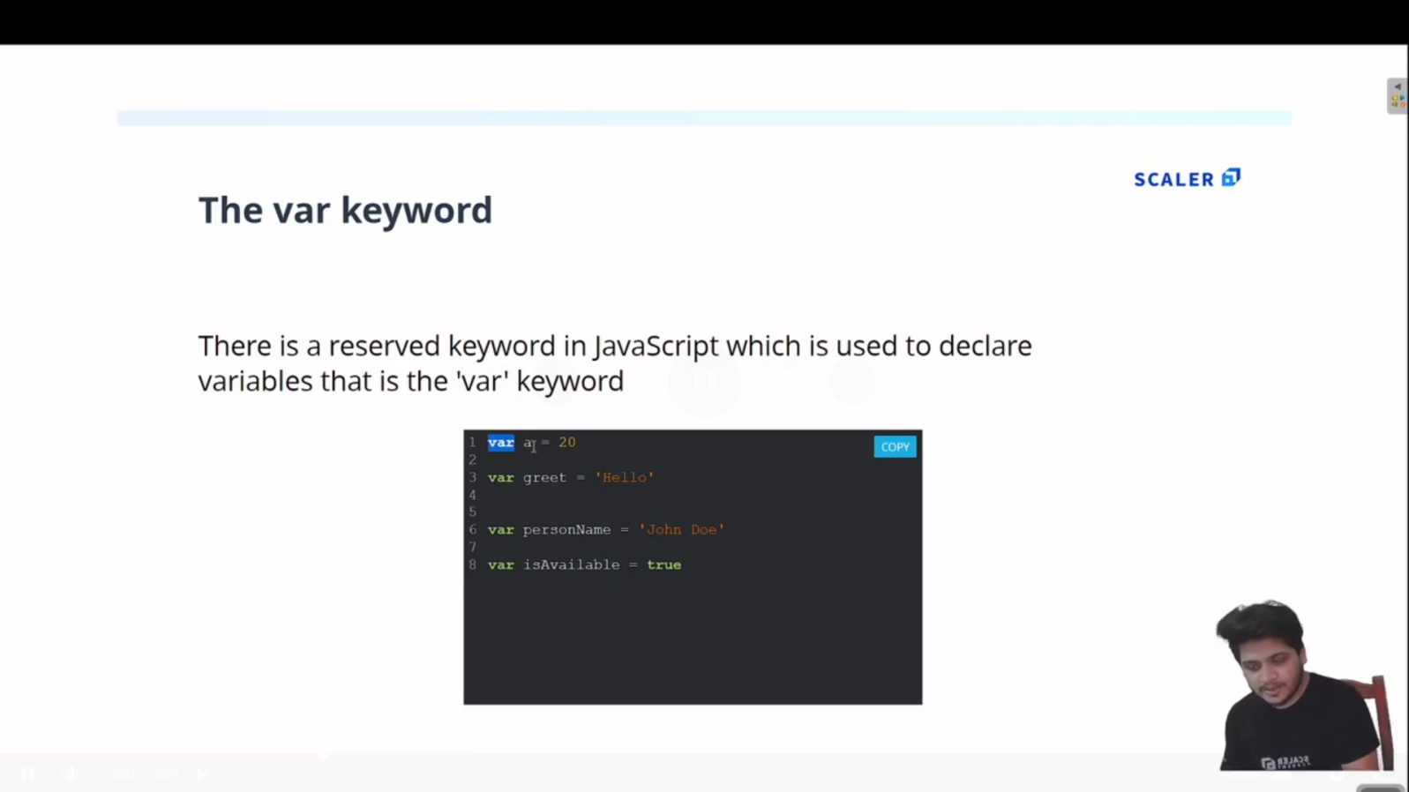

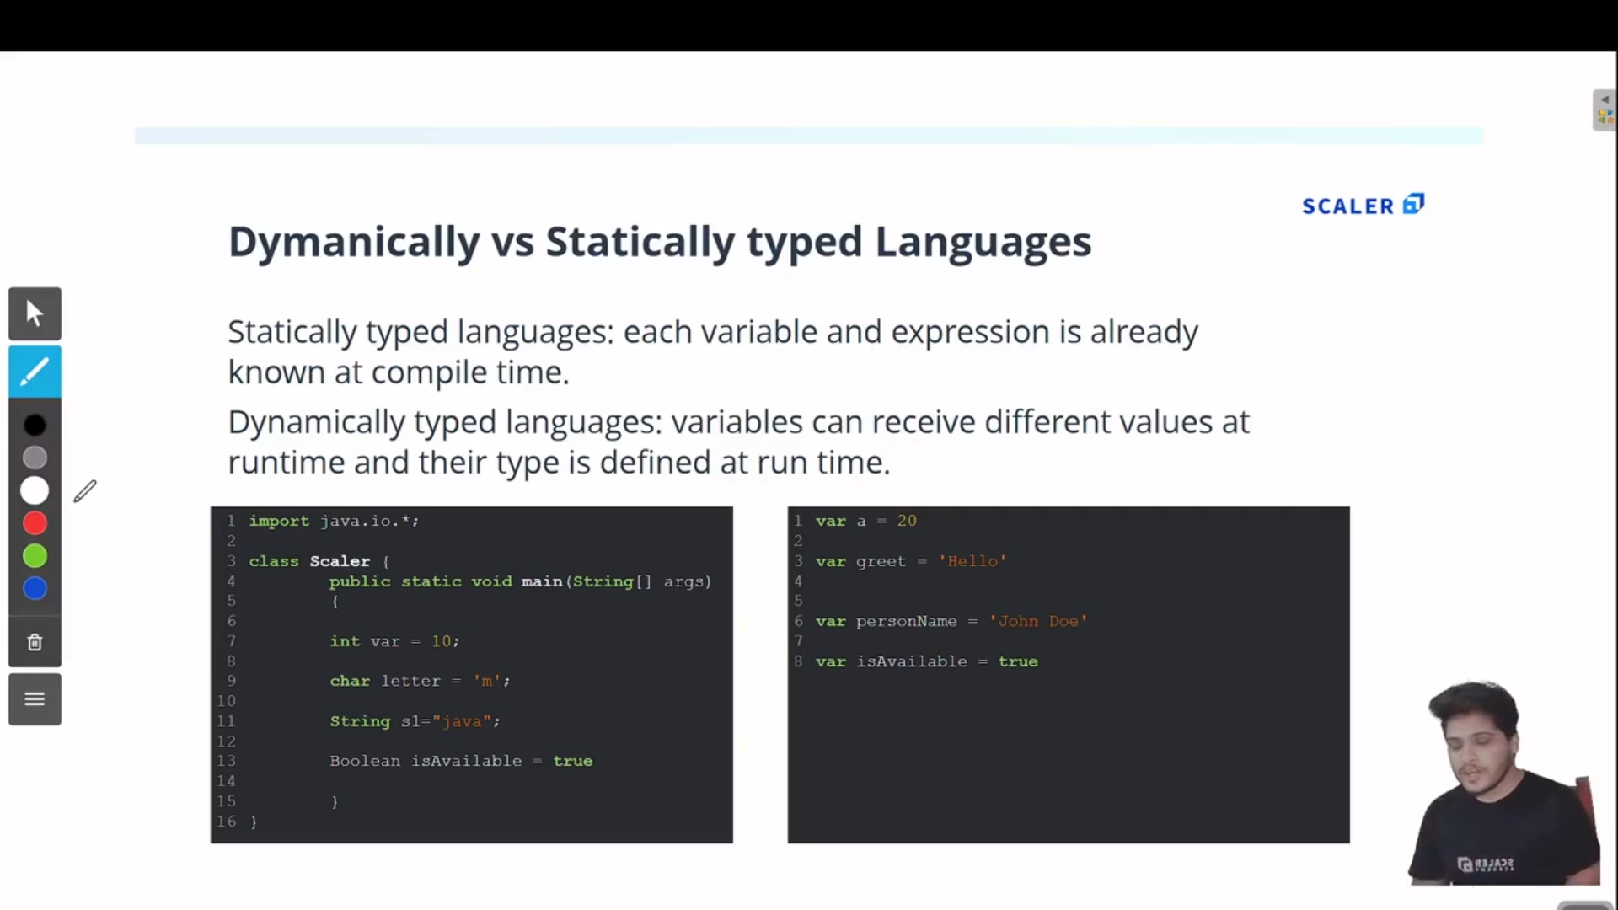

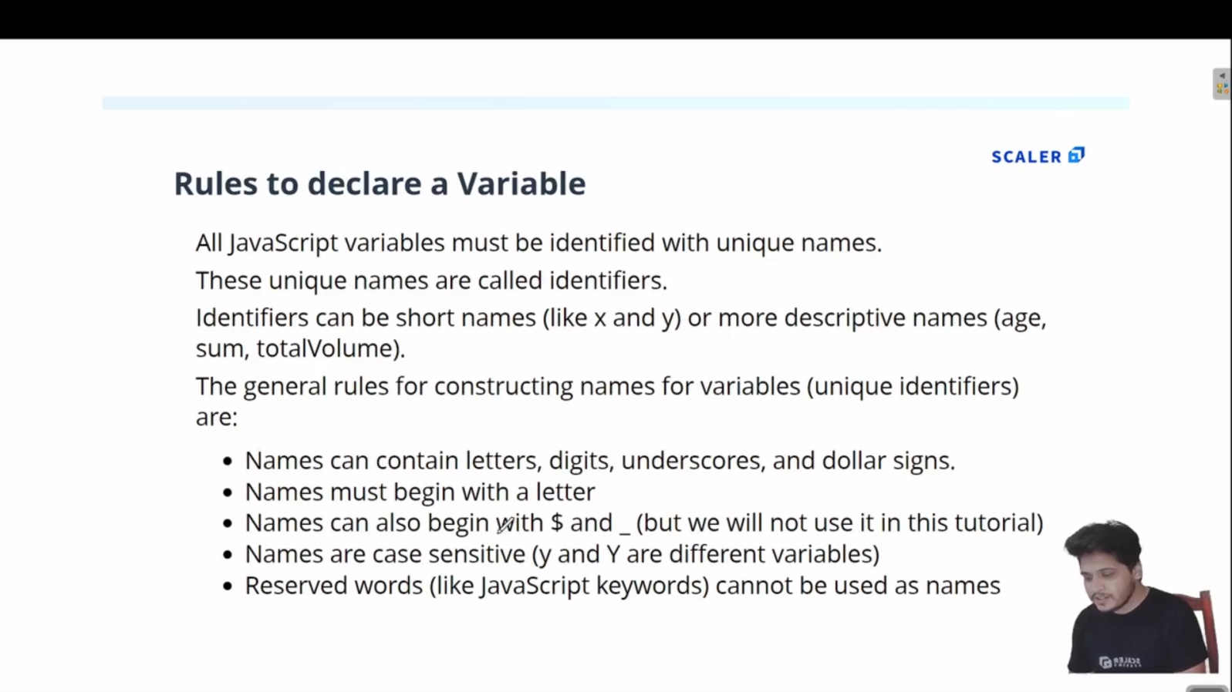

1. **Arrays in JS:**

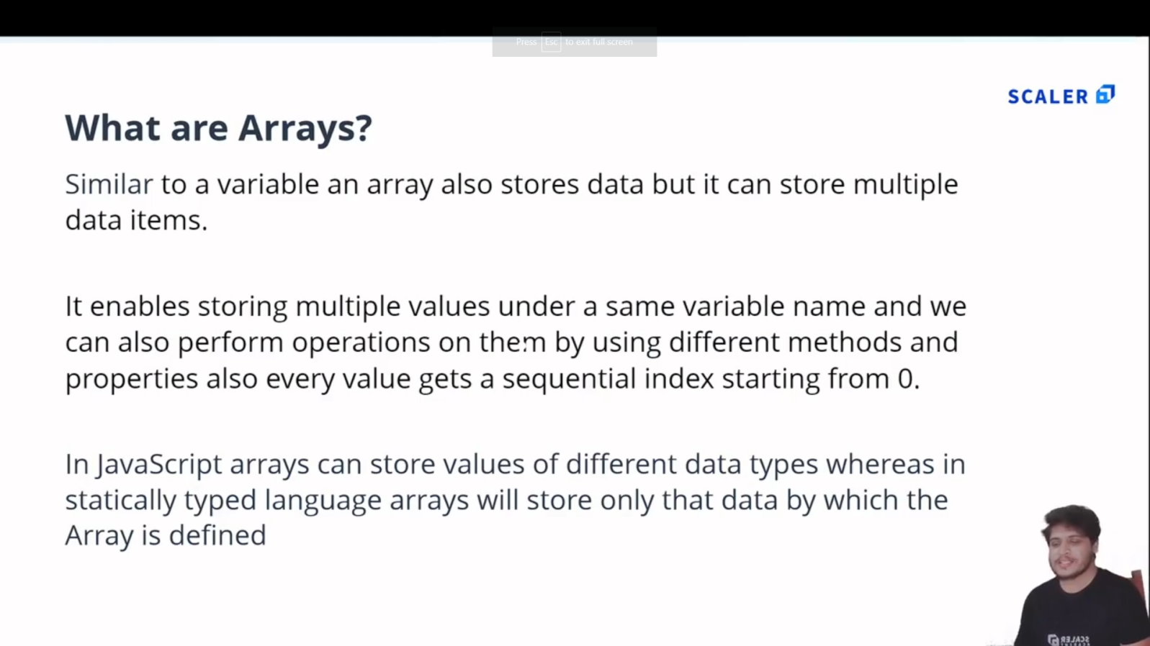

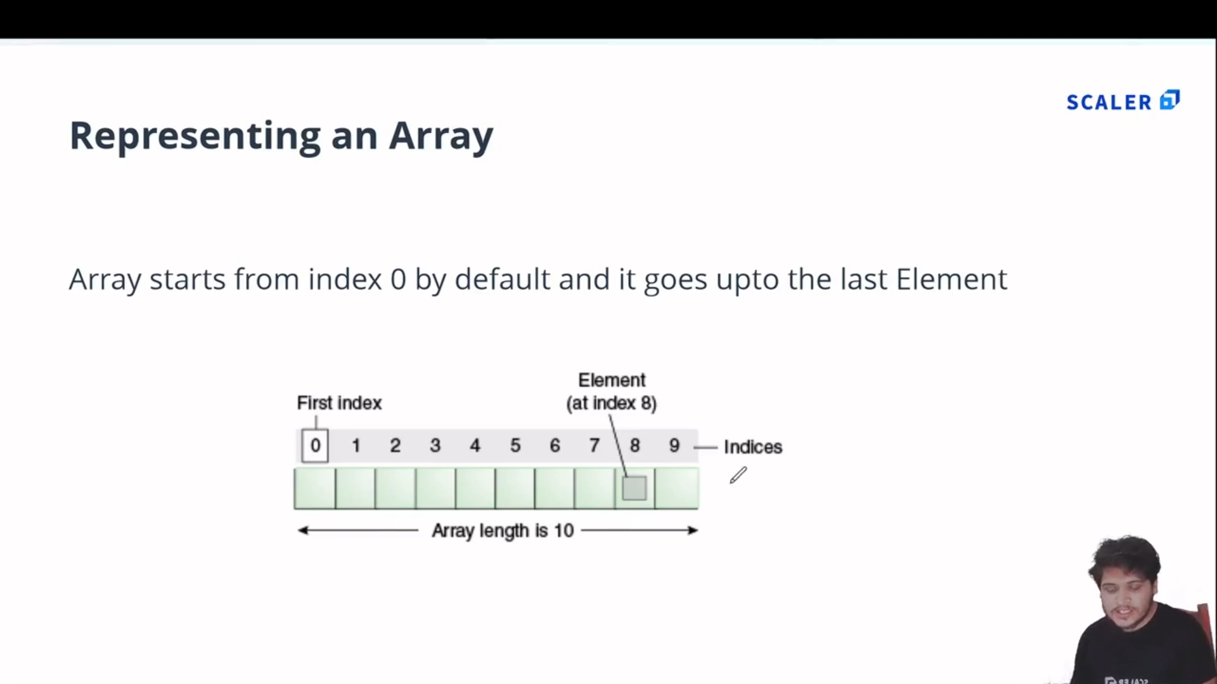

* 1. **Example:**

//Array : In JS Array can store multiple values of differnt datatypes

var arr = [12, 'Ferrari' , true , 12.4];

console.log(arr);

//Accessing Elements

var a = arr[0];

console.log(a);

//replacing array elememt

arr[1] = 'Bently';

console.log(arr[1]);

//length property

console.log('Length of array is : '+arr.length);

**Output:**

[Running] node "e:\MCA\COURSES\JAVASCRIPT\Js_certification@scalar\Module 2\array.js"

[ 12, 'Ferrari', true, 12.4 ]

12

Bently

Length of array is : 4

* 1. **Output:**

1. **Array Methods :[pop() , push() , shift() , unshift()]**

//------Inbuilt Array methods------------

//1.pop() method [REMOVES ELEMENT FROM END OF AN ARRAY]:

var arr2 = [12 , 14 , 56 , 57];

console.log('Array : '+arr2);

var c = arr2.pop();

console.log('Popped Element : '+c);

console.log('Array after popped : ', arr2);

//2.pop() method [PUSHES ELEMENT TO THE END  OF ARRAY]:

arr2.push(100);

console.log('\nArray after Push  : ', arr2);

//3.shift() method [REMOVES ELEMENT FROM START OF AN ARRAY]:

var d = arr2.shift();

console.log('\nShifted : ' + d);

console.log('Array after shift : ', arr2);

//4.unshift() method [PUSHES ELEMENT TO THE BEGINNING  OF ARRAY]:

arr2.unshift(102);

console.log('\nArray after Unshift : ', arr2);

**OUTPUT:**

[Running] node "e:\MCA\COURSES\JAVASCRIPT\Js_certification@scalar\Module 2\tempCodeRunnerFile.js"

Array : 12,14,56,57

Popped Element : 57

Array after popped :  [ 12, 14, 56 ]

Array after Push  :  [ 12, 14, 56, 100 ]

Shifted : 12

Array after shift :  [ 14, 56, 100 ]

Array after Unshift :  [ 102, 14, 56, 100 ]

[Done] exited with code=0 in 0.11 seconds

1. **Objects in JS :**
   1. **In JS Objects are in Key-Value pair:**

|  |  |
| --- | --- |
| **Code** | **Output** |
| //In JS Objects are in Key-Value Pair  var person = {      firstName : 'Muhammad',      secondName : 'Anshad',      age : 25 ,      ownsCar : false  }  console.log(person); | {    firstName: 'Muhammad',    secondName: 'Anshad',    age: 25,    ownsCar: false  } |

* 1. **Accessing values from Object :**

|  |  |
| --- | --- |
| **Code** | **Output** |
| //-----Accessing Values from Object ------  //1.Dot notation :  console.log(person.age);  //2.Bracket notation  console.log(person['firstName']); | 25  Muhammad |

* 1. **Objects can have Arrays and Objects can be Nested:**

|  |  |
| --- | --- |
| **Code** | **Output** |
| //An Object can have an Array inside it.  //Nested Objects are possible in JS .  var cap = {      firstName : 'Steve',      lastName : 'Rogers',      age : 102 ,      friends : ['Bucky Barnes' , 'Bruce Banner' , 'Tony Stark'],      isAvenger : true ,      address : {          state : 'New York',          city : {              name : 'Brooklyn',              pincode : 123456          }      }  }  //To Access 'Bruce Banner'  :  console.log(cap.friends[1]);  //To Access 'Brooklyn' :  console.log(cap.address.city.name);  //Updating isAvenger :  cap.isAvenger = false;  console.log(cap.isAvenger);  //ADD to  object  :  cap.movies = ['age of ultron','civil war','first avenger'];  console.log(cap);  //DELETE from Object :  delete cap.age;  console.log(cap); | Bruce Banner  Brooklyn  False  {    firstName: 'Steve',    lastName: 'Rogers',    age: 102,    friends: [ 'Bucky Barnes', 'Bruce Banner', 'Tony Stark' ],    isAvenger: false,    address: { state: 'New York', city: { name: 'Brooklyn', pincode: 123456 } },    movies: [ 'age of ultron', 'civil war', 'first avenger' ]  }  {    firstName: 'Steve',    lastName: 'Rogers',    friends: [ 'Bucky Barnes', 'Bruce Banner', 'Tony Stark' ],    isAvenger: false,    address: { state: 'New York', city: { name: 'Brooklyn', pincode: 123456 } },    movies: [ 'age of ultron', 'civil war', 'first avenger' ]  } |

1. **Conditional Statements in JS (reference:codecademy):**
   1. If statement.

let sale =true;

sale=false;

if (sale) {

  console.log('Time to buy!');

}

* 1. If...Else Statement.

let sale = true;

sale = false;

if(sale) {

  console.log('Time to buy!');

}

else{

  console.log('Time to wait for a sale.');

}

* 1. Comparison Operators.(<,>,<=,>=,===,!==)

let hungerLevel = 7;

if (hungerLevel > 7){

  console.log('Time to eat!');

}

else{

  console.log('We can eat later!');

}

* 1. Logical Operators. (&&,||,!)

let mood = 'sleepy';

let tirednessLevel = 6;

if(mood === 'sleepy' && tirednessLevel > 8){

  console.log('time to sleep');

}

else{

  console.log('not bed time yet');

}

* 1. Truthy and Falsy.

let myVariable = 'I Exist!';

if (myVariable) {

   console.log(myVariable)

} else {

   console.log('The variable does not exist.')

}

* (The code block in the if statement will run because myVariable has a truthy value,even though the value of myVariable is not explicitly the value true).
* **The list of falsy values includes**:

[ 0, Empty strings like "" or '' ,null ,undefined ,NaN ].

let wordCount = 1;

if (wordCount) {

  console.log("Great! You've started your work!");

} else {

  console.log('Better get to work!');

}

let favoritePhrase = '';

if (favoritePhrase) {

  console.log("This string doesn't seem to be empty.");

} else {

  console.log('This string is definitely empty.');

}

* 1. Truthy and Falsy Assignment.
* The code below checks if username is defined and assigns a default string if it is not:

let username = '';

let defaultName;

if (username) {

  defaultName = username;

} else {

  defaultName = 'Stranger';

}

console.log(defaultName);

OR use the || operator :

let username = '';

let defaultName = username || 'Stranger';

console.log(defaultName);

* 1. Ternary Operator.

Example1:

isNightTime ? console.log('TRUE') : console.log('False section');

Example.2:

let favoritePhrase = 'Love That!';

favoritePhrase === 'Love That!'

?

  console.log('I love that!')

:

  console.log("I don't love that!");

* 1. Else If Statements.

let season = 'summer';

if (season === 'spring') {

  console.log('It\'s spring! The trees are budding!');

}

else if(season === 'winter'){

  console.log('It\'s winter! Everything is covered in snow.');

}

else if(season === 'fall'){

  console.log('It\'s fall! Leaves are falling!')

}

else if(season === 'summer'){

  console.log('It\'s sunny and warm because it\'s summer!');

}

else {

  console.log('Invalid season.');

}

* 1. The switch keyword.

let athleteFinalPosition = 'first place';

switch (athleteFinalPosition){

  case 'first place':

    console.log('You get the gold medal!');

    break;

  case 'second place':

    console.log('You get the silver medal!');

    break;

  case 'third place' :

    console.log('You get the bronze medal!');

    break;

  default :

    console.log('No medal awarded.');

    break;

}

1. **Asd**
2. **asd**